Crypto-correctionBitcoin and its rivals offer no shelter from the storm
Indeed, crypto-plunges make other asset prices look tame
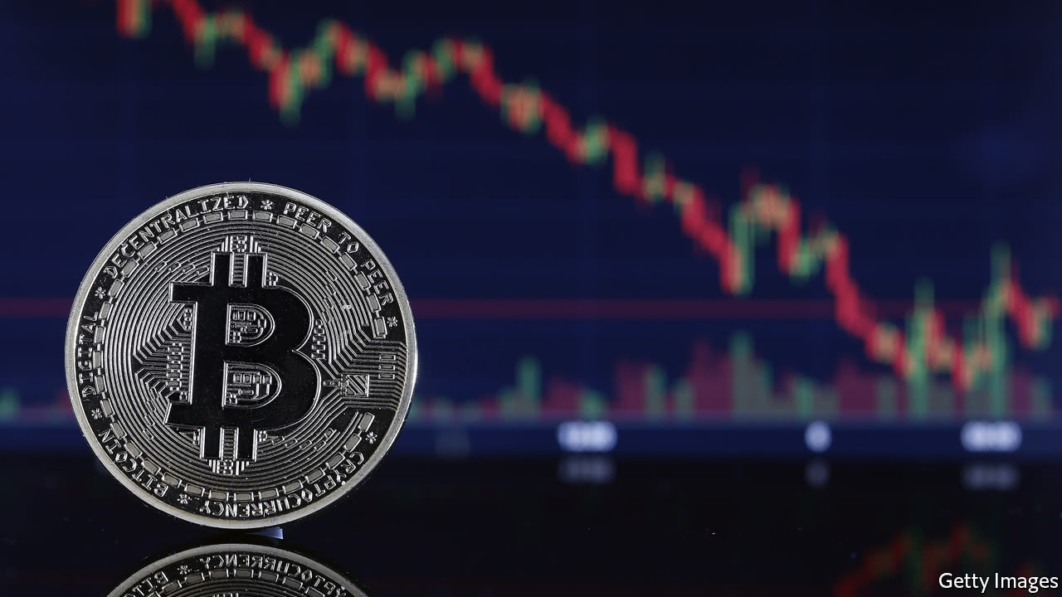

Print edition | Finance and economics
Feb 10th 2018
THE “biggest bubble in human history comes down crashing,” tweeted Nouriel Roubini, an economist, gleefully. After an exhilarating ride skywards in 2017, investors in crypto-currencies have been rudely reminded that prices can plunge earthwards, too. In mid-December the price of bitcoin was just shy of $20,000; by February 6th, it had fallen to $6,000, before recovering a little (see chart).
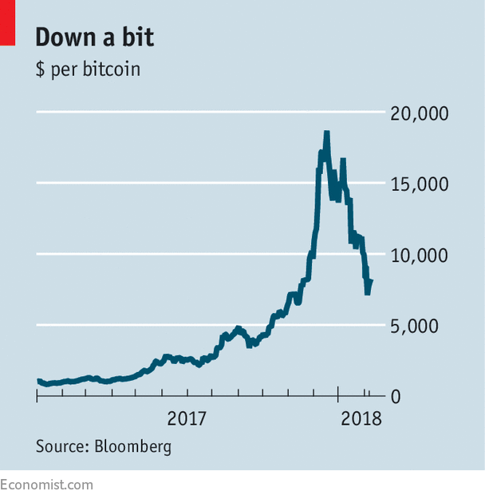
And bitcoin is not the only digital currency to have fallen. Figures from CoinMarketCap, a website, show that the total market capitalisation of crypto-currencies has fallen by more than half this year, to under $400bn. This slide has taken place amid a flurry of hacks, fraud allegations and a growing regulatory backlash.
Perhaps the most damaging allegations surround Tether, a company that issues a virtual currency of the same name. Tether allows users to move money across exchanges and crypto-currencies without converting it back into “fiat” (central-bank-backed) money first. In theory, each Tether is worth one dollar, and the company has enough greenbacks to redeem them all. But critics allege that the currency may simply have been used to prop up bitcoin. They say that suspiciously large quantities of Tether were issued whenever the bitcoin price was low, and were allegedly traded for bitcoin on Bitfinex, a large currency exchange. It is not known if Tether has the $2.2bn needed to back its outstanding tokens. Its relationship with its auditor appears to have ended in recent months.
The company itself has been silent (including in responding to The Economist). Both Tether and Bitfinex—which are reported to have the same boss—are under investigation by regulators in America. Should the suspicions prove true, a further rush out of crypto-currencies might follow.
Recent weeks have seen other bad news. In Japan authorities raided the offices of Coincheck, a virtual-currency exchange, after $530m was stolen in the largest ever crypto-theft. In America regulators shut down an “initial coin offering” (which raises funds by selling digital “tokens”) by AriseBank, alleging an investor scam. And BitConnect, a platform that borrowed customers’ crypto-currency in exchange for monthly returns, folded in mid-January following allegations that it was running a Ponzi scheme. At its peak the company was valued at around $2.5bn.
Regulators continue to weigh in. Bitcoin “has become a combination of a bubble, a Ponzi scheme and an environmental disaster”, Agustín Carstens, the head of the Bank for International Settlements, warned this week, calling for more oversight. National authorities are obliging. Chinese regulators have banned crypto-currency trading on both domestic and foreign platforms, and the Indian finance minister has promised to crack down on their use for illicit activities. In America the heads of the Commodities Futures Trading Commission and the Securities and Exchange Commission, two regulators, testified to a Senate Committee this week; they agreed on the need to protect investors, albeit without stifling innovation.
Banks, too, are alert to trouble—from potential losses, particularly on unsecured lending, or from falling foul of anti-money-laundering rules. Several, including Citigroup and JPMorgan Chase in America, and Lloyds in Britain, took the unusual step of banning customers from buying crypto-currencies with their credit cards.
Diehard believers—dubbed “crypto-crazies” by Mr Roubini, who is the opposite—see such restrictions as a typical backlash designed to sow fear about a disruptive technology. But more moderate crypto-proponents concede that regulation can help. Albert Wenger of Union Square Ventures, a venture-capital firm, says that rules making it easier for investors to distinguish between good and bad projects will take time to design, but should ultimately support the market. And greater regulatory certainty could convince even conservative institutional investors to dive in, argues Matthew Goetz of BlockTower Capital, an investment firm. After all, concerns about exchanges and scams are hardly new. Bitcoin weathered a fall of 85% between 2013 and 2015 after Mt Gox, then the largest virtual-currency exchange, was hacked and collapsed.
The price falls, however, may have scared off some investors. Sarit Markovich of Northwestern University’s Kellogg School of Management says that many retail investors bought crypto-currencies not out of rational calculations but for fear of missing out. They have learned they are not a one-way bet. That stockmarkets and crypto-currencies fell in tandem on February 5th may also have scotched another notion: that bitcoin, a sort of “digital gold”, would benefit from a flight to safety.
This article appeared in the Finance and economics section of the print edition under the headline "Crypto-correction"

